Project Milestone II
Multi-Agent Workflow

AthleteEdge Intelligence Platform

Ariana Anderson
March 22, 2026
GitHub Repository: https://github.com/arianaanderson113?tab=repositories

Agent Architecture Diagram
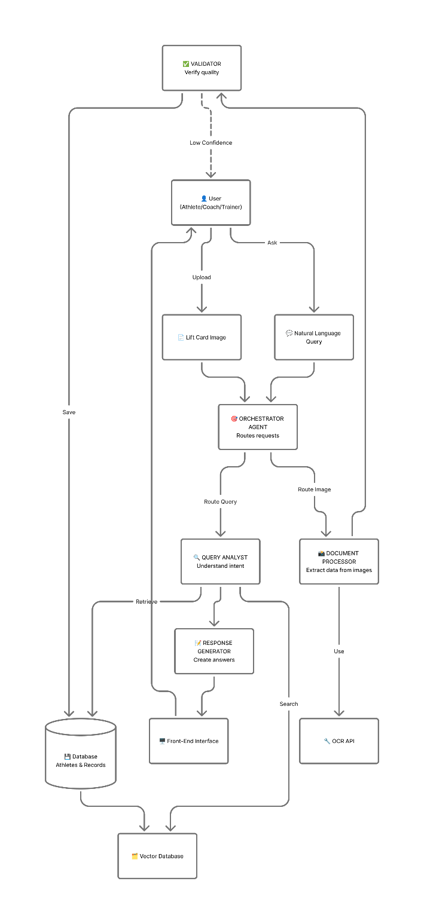

Feature 1: Scan Lift Card
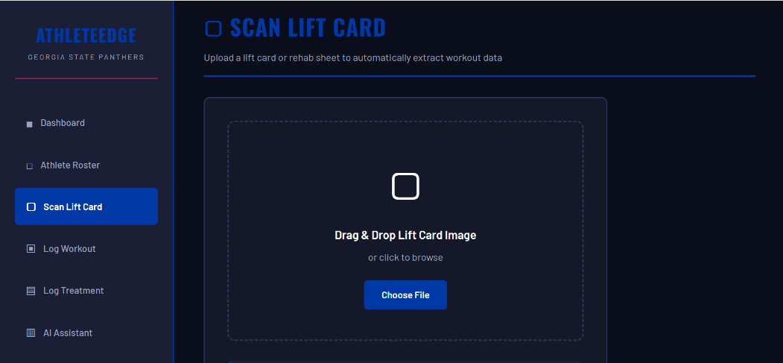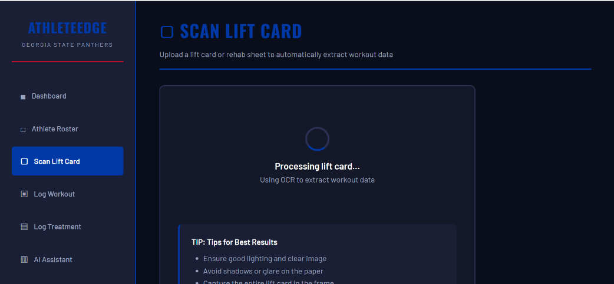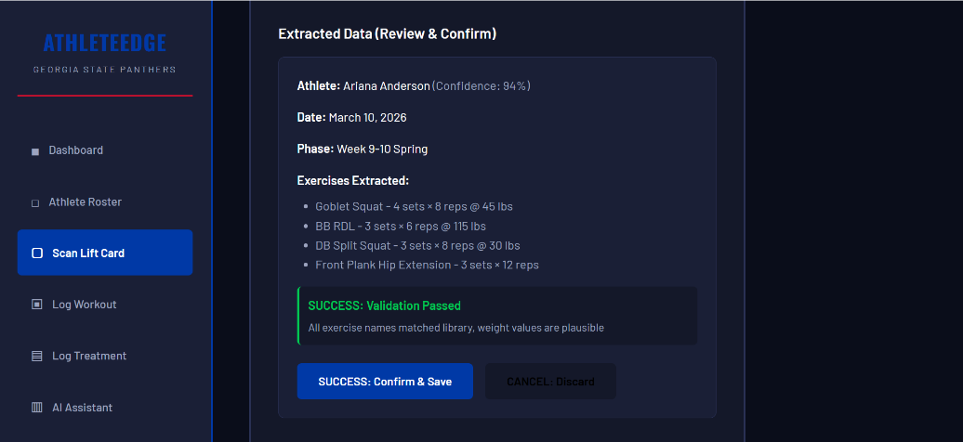

Feature 2: AI Assistant
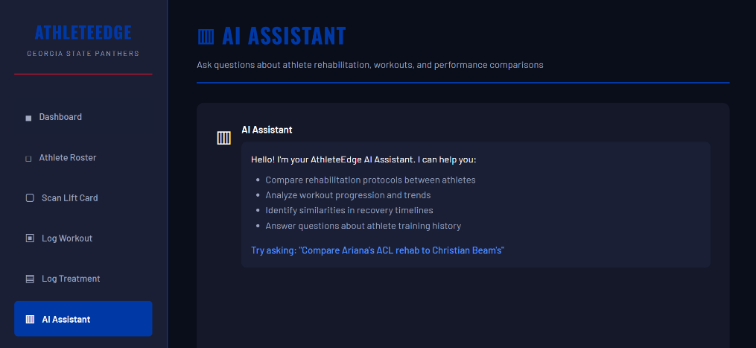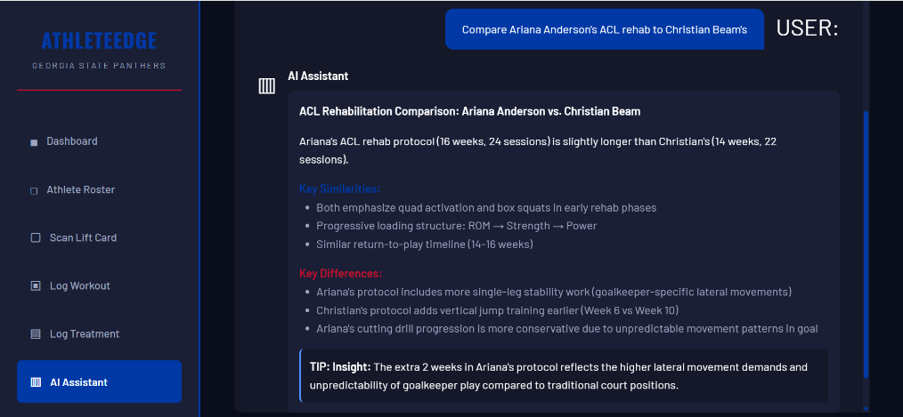

Complete Documentation Available At:

GitHub Repository: https://github.com/arianaanderson113?tab=repositories

Design Document:
https://github.com/arianaanderson113/athleteedge-dashboard/blob/main/docs/MILESTONE_II_DESIGN_DOCUMENT.md

Python Code:
https://github.com/arianaanderson113/athleteedge-dashboard/blob/main/backend/athleteedge_agents.py

Updated Interface:
https://github.com/arianaanderson113/athleteedge-dashboard/blob/main/frontend/athleteedge-gsu-v2-with-ai.html

